Objectives:
The objective of this lab report is to analyze the impact of government expenditure on key macroeconomic variables using a distributed lag model implemented in C. This model captures the delayed effects of fiscal policy on investment (I), output (Y), tax revenue (T), and consumption (C) over a five-year period. By incorporating past values of output into the calculations, the study aims to examine how changes in government spending influence economic growth over time.
Source Code:
#include <stdio.h>
int main() {
// Given data
double G[] = {20, 25, 30, 35, 40}; // Government expenditure for each year
double Y_prev = 80; // Initial Y (Y_-1)\
double I, Y, T, C;
double growth_in_consumption;
int year; // Declare the variable here
// Loop through 5 years
printf("Year\tG\tI\tY\tT\tC\tGrowth in Consumption\n");
for (year = 0; year < 5; year++) { // Use the declared variable
// Calculate I
I = 2 + 0.1 * Y_prev;
// Calculate Y
Y = 45.45 + 2.27 * (I + G[year]);
// Calculate T
T = 0.2 * Y;
// Calculate C
C = 20 + 0.7 * (Y - T);
// Calculate growth in consumption
growth_in_consumption = C - (20 + 0.7 * (Y_prev - 0.2 * Y_prev));
printf("%d\t%.2f\t%.2f\t%.2f\t%.2f\t%.2f\t%.2f\n", year + 1, G[year], I, Y, T, C, growth_in_consumption);
// Update Y_prev for the next year
Y_prev = Y;
}
return 0;
}
Output:
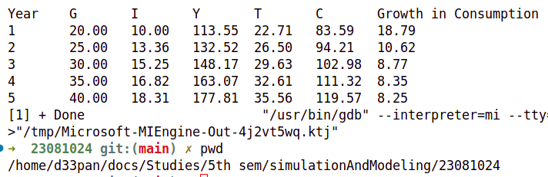

Conclusion:
The simulation of the distributed lag model captures the delayed effects of fiscal policy by iterating economic variables over time. The results show that increases in government spending led to higher investment, output, and consumption, with these effects propagating gradually. The model highlights that consumption growth depends not only on current income but also on past economic conditions, demonstrating the importance of lagged responses in economic simulations.

